Capstone Project Weekly Progress Report
Semester | Fall-2024 Semester 3rd
Course Code | AML-3406
Section | Section 1
Project Title | Car Damage Detection
Group Name | Group B
Student names/Student IDs | Sakshi (C0908000)  Bansil Patel (C0912873) – TL  Harsh Mohile (C0912872)  Meet Patel (C0910378)  Rachit Bhatt (C0902810)
Reporting Week | Week 5
Faculty Supervisor | William Pourmajidi

Grade the level of collaboration from different aspects between team members:
(use: good, medium, below expectation)
Sakshi | Bansil Patel | Harsh Mohile | Meet Patel | Rachit Bhatt
Good | Good | Good | Good | Good

Tasks outlined in the previous Weekly Progress Report for this reporting week at the individual level and group level
  - Individual tasks (each team member)
Sakshi: Research on CI/CD Pipelining for ML-Ops.
Bansil Patel & Meet Patel: Applying various models initially on the dataset.
Harsh Mohile & Rachit Bhatt: Research on Docker for Deployment.
2.2 Your team’s tasks
- Exploring and understanding the dataset.
- Research on Docker for Deployment.

Progress made in Reporting Week at an individual level and group level
  - Individual progress
Sakshi: Studied the theoretical concepts of CI/CD.
Bansil Patel: Applied regular NN with Model Evaluation and attempted in accessing the annotated data in the JSON files.
Harsh Mohile & Rachit Bhatt: Collaborated to create a demo project using Docker.
  - Your team’s progress
- Worked on understanding Docker by creating a demo project; GitHub - Docker.

The areas/tasks you could not make progress and/or complete as scheduled or the difficulties encountered in this reporting week at individual level and group level.
  - Individual project blockers
Sakshi: N/A
Bansil Patel & Meet Patel: AttributeError exception generated when trying to access the JSON files.
Harsh Mohile & Rachit Bhatt: Docker installation and implementation on Windows platform was a little challenging when finding proper content for research and development.
  - Your team’s project blockers
- Faced a progress blocker in the form of exception when trailing with JSON files; seems like an OS-level error due to some path or incorrect data provided to the library.

Tasks to be completed in next week at individual level and group level
  - Individual tasks
Sakshi: Implementation CI/CD on a demo project.
Bansil Patel | Harsh Mohile | Meet Patel: Resolve the exception and implement multi-model approach.
Rachit Bhatt: Start Implementing CI/CD using Docker through GitHub.
  - Your team’s tasks
- Work on multi-model setup.
- Implement CI/CD using Docker with GitHub.

Include the tasks from your sprint planning (Github/Zenhub) for the present period.
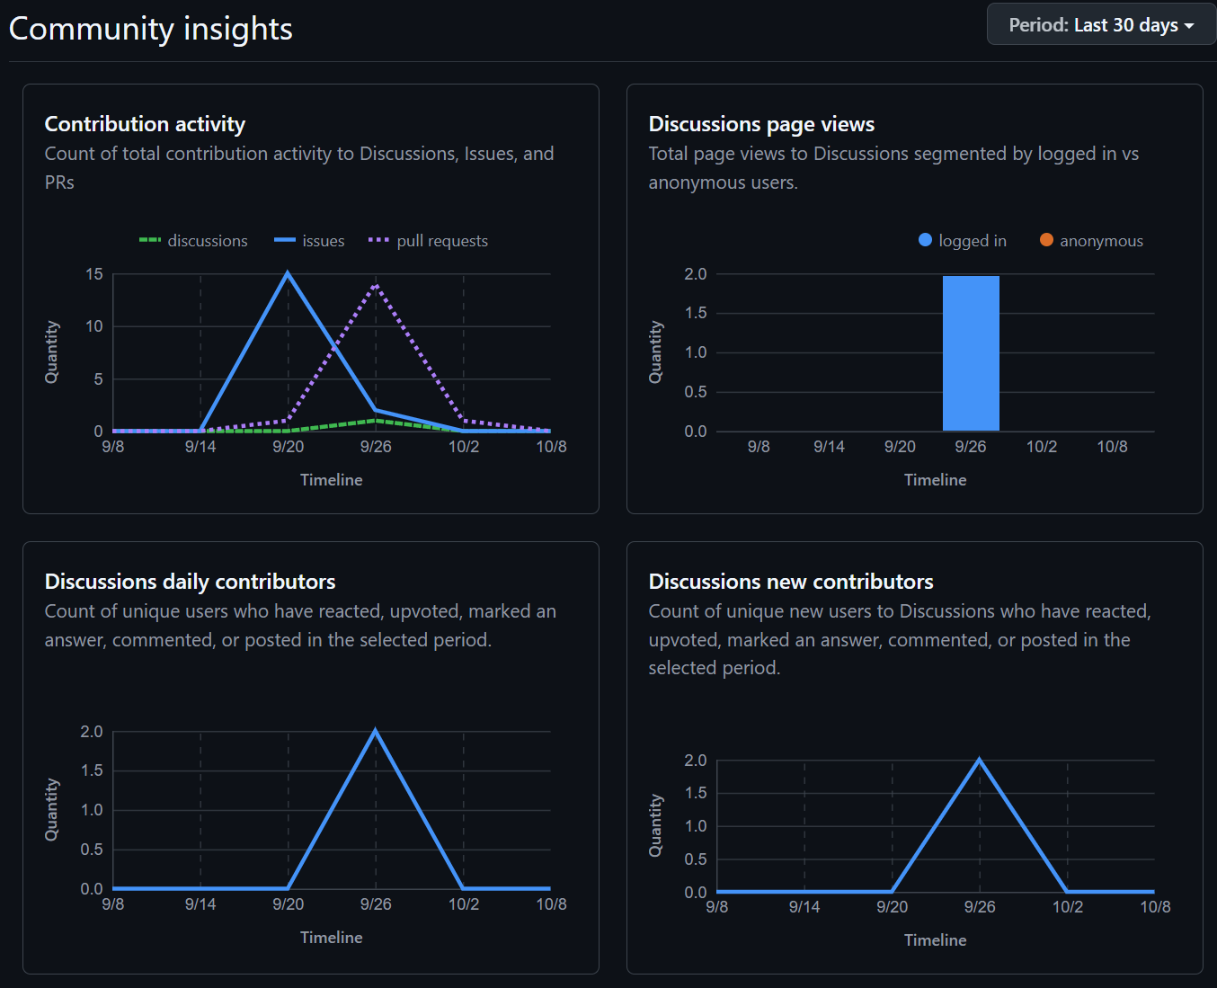
Figure 1: Weekly Activities
- In this week, there were 15 issues resolved with numerous PRs, contributing in development.

Include charts/graphs (e.g., burn down charts) from your project management tool (Github/Zenhub) that shows your progress for the period of this report.
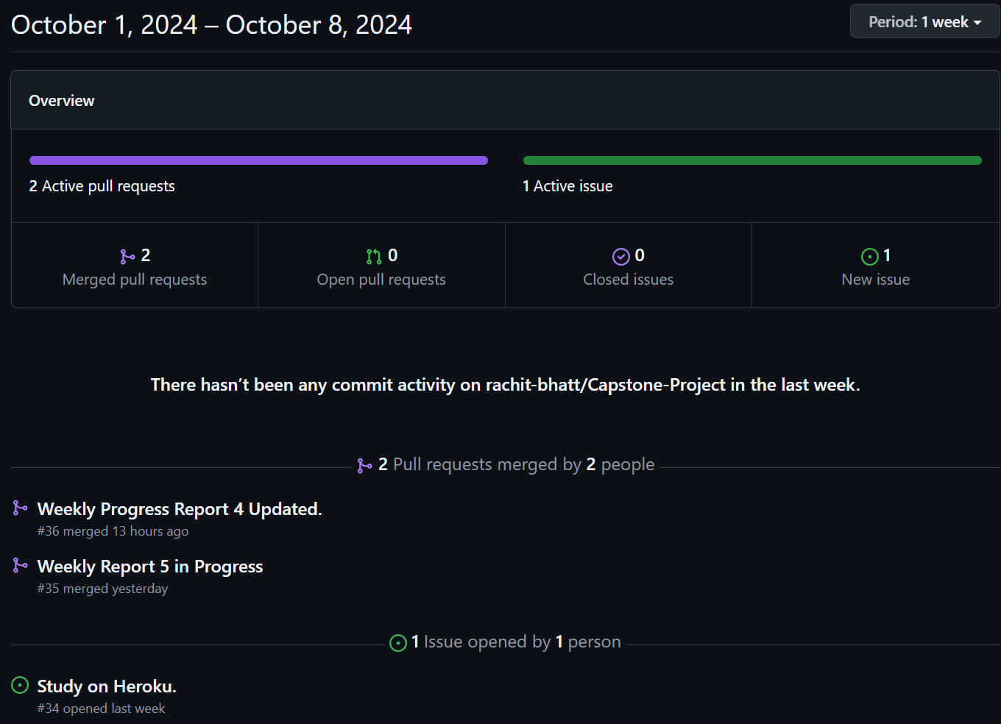
Figure 2: Contributors in the Week
- This week, there were two pull requests generated and merged that included phase 1 of our project and documentation.
- The one active issue we dealt with was the exception generated as shown in the Figure 3, took a lot of time and decided to shift it to the next scrum.

Include a note and address to your project Github with list of codes uploaded/updated on Github in this reporting week.
GitHub: https://www.github.com/rachit-bhatt/Capstone-Project
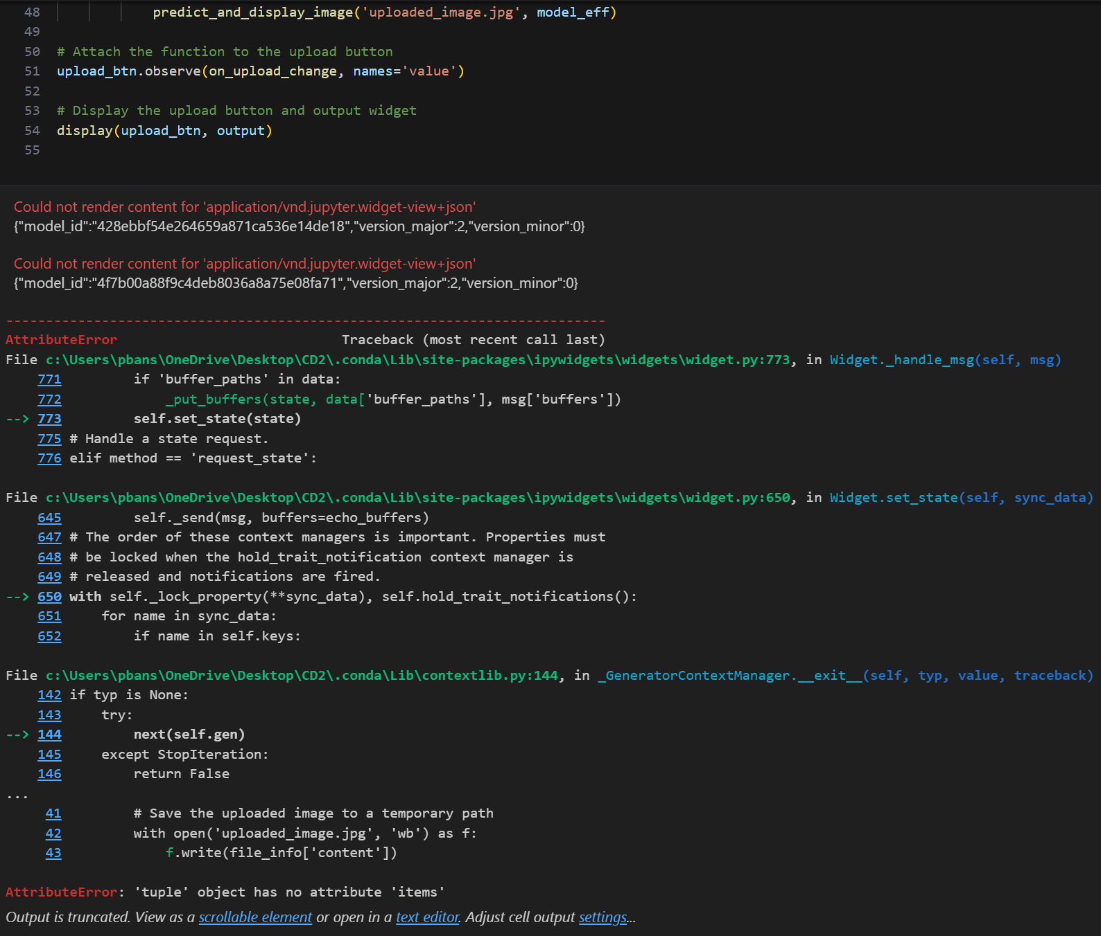
Figure 3: Exception – Progress Blocker
- The exception when dealing with the image by the end user.
- Expecting it to be resolved in the next scrum.

